**ASSIGNMENT -7.2**

1. Write a program to implement word count using Pig.

* FILE IN WHICH WORDS ARE TO BE COUNTED

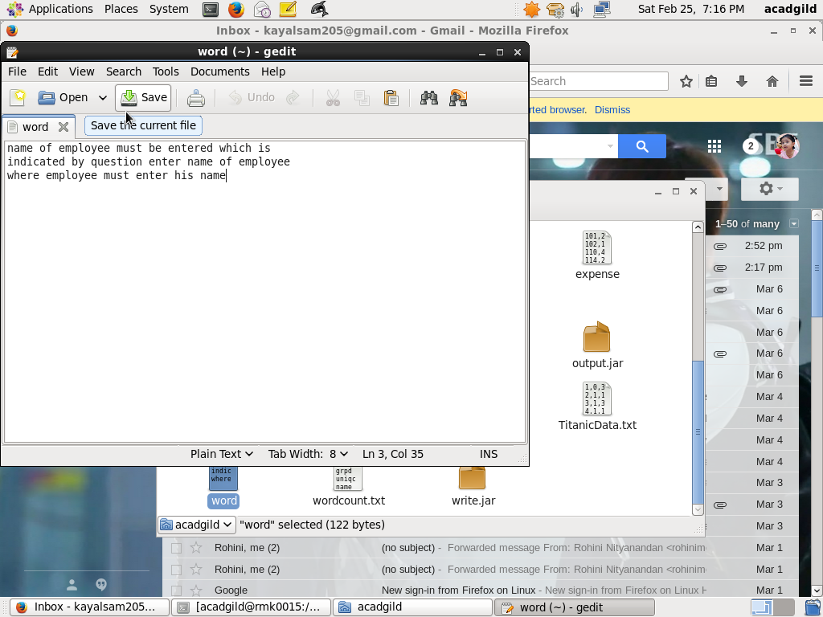

* MOVING THE FILE TO A DESIRED LOCATION

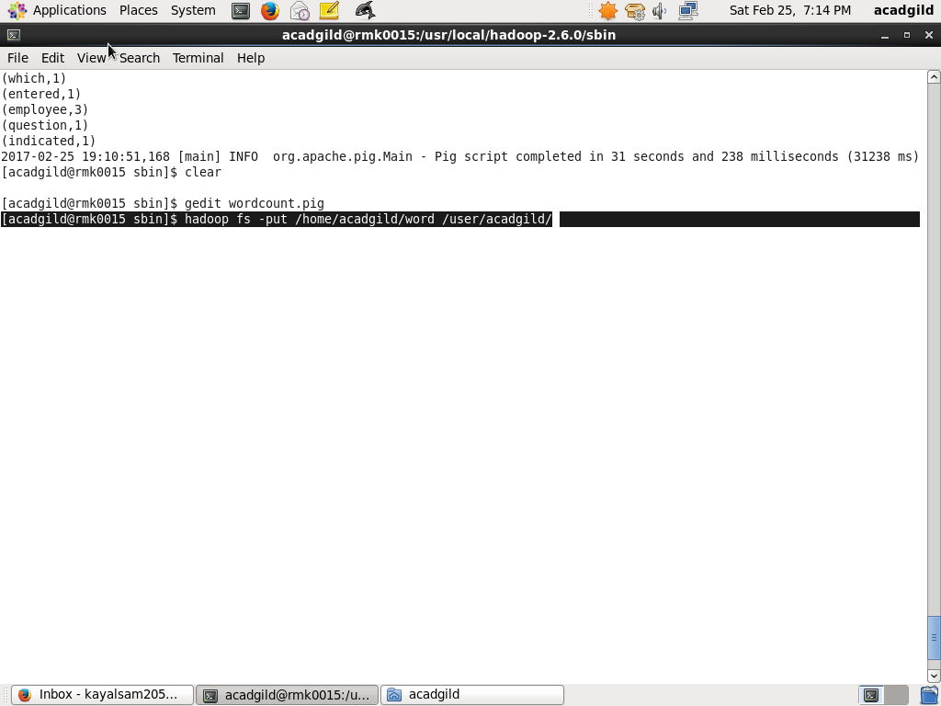

* OPENING A PIG FILE AND WRITING A PROGRAM

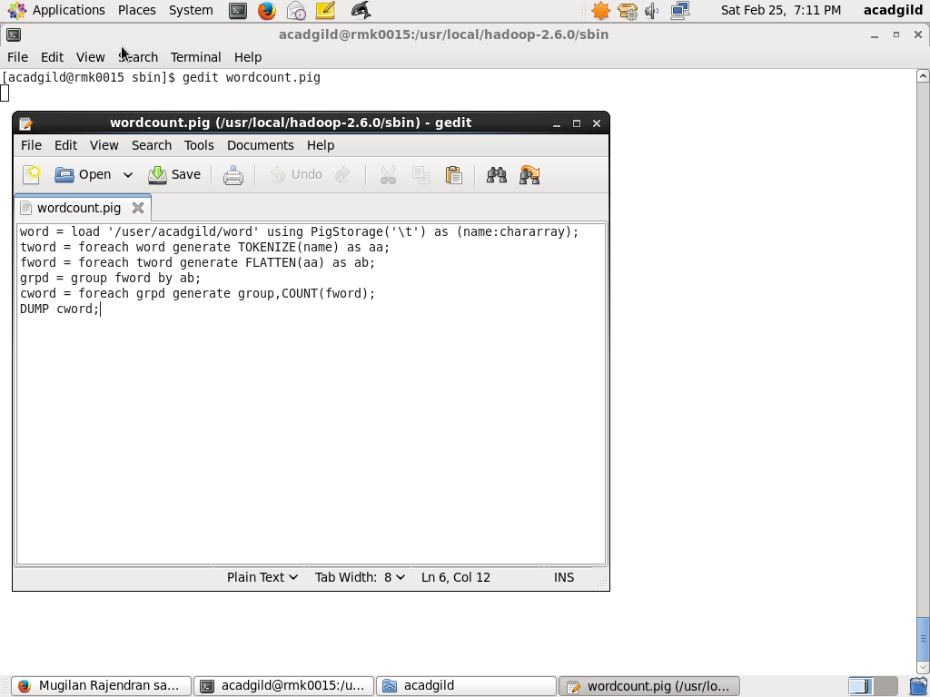

* EXECUTING THE PIG FILE

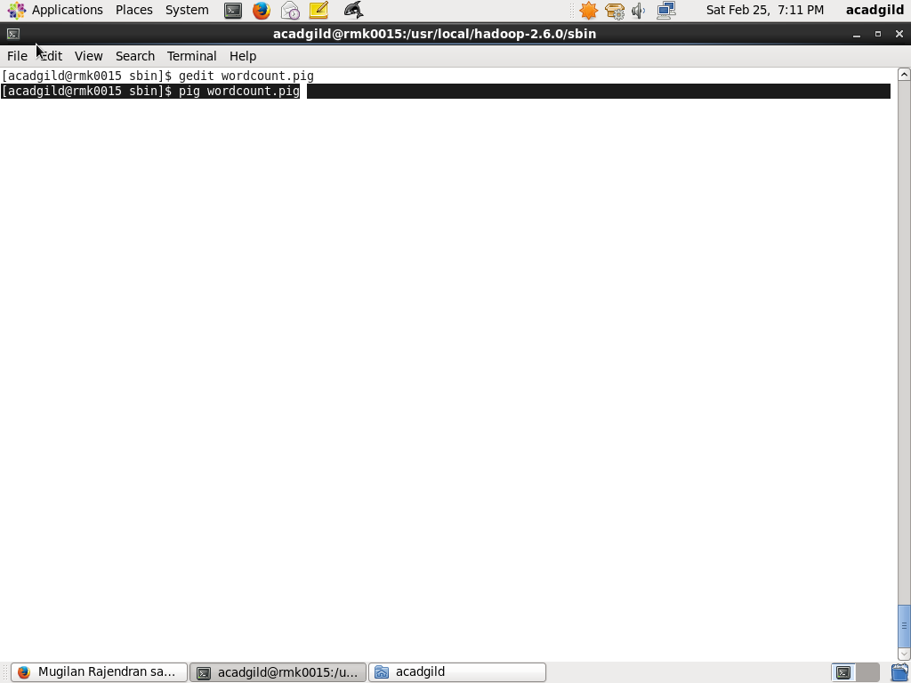

* **FINAL OUPUT**

